The Chapel Willington MK44 3QH
Concert
MUSICAL SHOWSTOPPERS
IN BRASS AND SONG
by The Gadsden Band
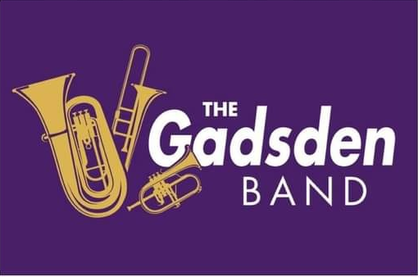

Saturday 18th October at 7.30pm
entry £8.00
Light refreshments * Raffle
Book with Shane 07813 214364
or Pat 07596 730725

