The Chapel Willington
Lunch Tuesday 14th
^{October 12.30-2.00}

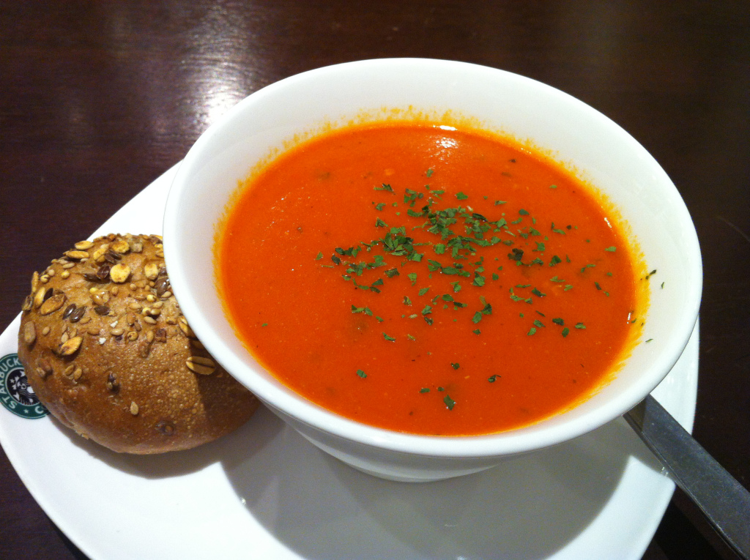
Raffle + Bring and Buy Stall
Enjoy good food in friendly atmosphere
Two courses £6.00
Book your place with Pat
01234 838667 07596 730725

